Experiments

Now we consider images of calm (a) and disturbed (b) sea surfaces.



a

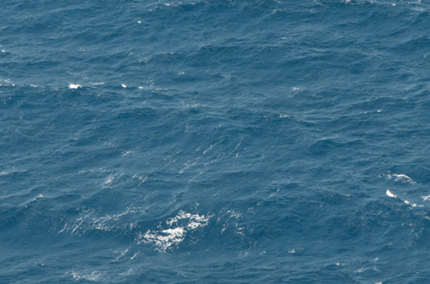

b

Calculation of values of density functions gave diapason [1.73,2.23] for a) and [1.52,2.42] for b). We note that more wide diapason show more complex structure of the image.

Level sets were constructed with step 0.1.

Graphics of multifractal spectra are given below.

Fig. Multifractal spectrum for a)

Fig. Multifractal spectrum for b)

Level sets for image a) are shown below. These sets illustrate a decomposition of an image on

nonintersecting subsets. Each subset contains pixels having density function value in interval [a,a+0.1), where a=1.73,1.83,..

 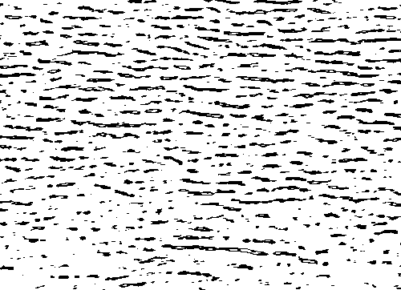

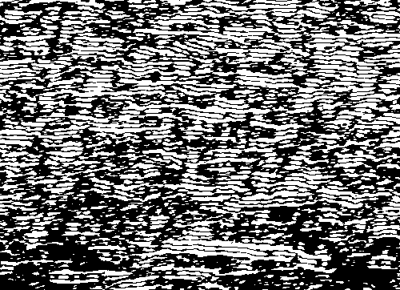 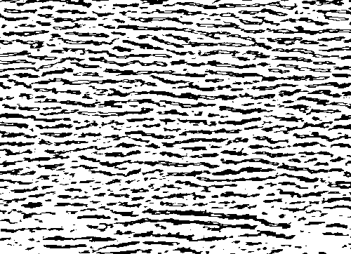



The corresponding graphic show values of fractal dimensions of these sets.

References

1. E. Gurevich, N. Ampilova, I. Soloviev. “On a natural-science investigation of the ultralow doses effect”, *Proc. 8 Int. Conf. CEMA13*, 17-19 Oct. 2013, Sofia, Bulgaria. pp. 85-88.
2. N. Ampilova, I. Soloviev. Fractal analysis methods in investigation of low doses effects . Proc. 12 Int. Conf. CEMA17, 12-14 Oct. 2017, Sofia, Bulgaria, p. 10-14. ISSN: 1314-2100, Изд. KING 2001, Sofia.
3. Н.Ампилова, Е.Куликов, В. Сергеев, И. Соловьев. Методы фрактального анализа в исследовании изображений биомедицинских препаратов, эл.журнал “Дифференциальные уравнения и процессы управления”, 1,2018, c.109-125, <http://www.math.spbu.ru/diffjournal/pdf/ampilova3.pdf>
4. Yong Xu, Hui Ji, Cornelia Fermuller, “Viewpoint Invariant Texture Description Using Fractal Analysis”, *Int. J. Comp. Vis,* 2009, 83, pp. 85-100.